1.Query all columns for all American cities in the **CITY** table with populations larger than 100000. The **CountryCode** for America is USA.

The **CITY** table is described as follows:

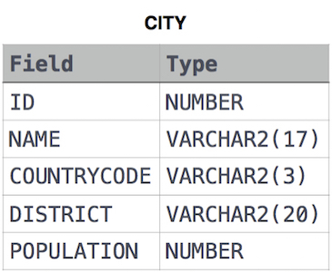

Ans:

SELECT * FROM CITY

WHERE POPULATION >100000 AND COUNTRYCODE = 'USA';

2. Query the **NAME** field for all American cities in the **CITY** table with populations larger than 120000. The CountryCode for America is USA.

The **CITY** table is described as follows:  


Ans:

SELECT NAME FROM CITY

WHERE POPULATION > 120000 AND COUNTRYCODE = 'USA';

3. Query all columns for a city in **CITY** with the ID 1661.

The **CITY** table is described as follows:  


Ans:

SELECT * FROM CITY WHERE ID=1661;

4. Query all columns (attributes) for every row in the **CITY** table.

The **CITY** table is described as follows:  


Ans:

SELECT * FROM CITY;

5. Query all attributes of every Japanese city in the **CITY** table. The **COUNTRYCODE** for Japan is JPN.

The **CITY** table is described as follows:  


Ans:

SELECT * FROM CITY WHERE COUNTRYCODE = 'JPN';

6. Query the names of all the Japanese cities in the **CITY** table. The **COUNTRYCODE** for Japan is JPN.  
The **CITY** table is described as follows:  


Ans:

SELECT NAME FROM CITY

WHERE COUNTRYCODE ='JPN';

7. Query a list of **CITY** and **STATE** from the **STATION** table.  
The **STATION** table is described as follows:  
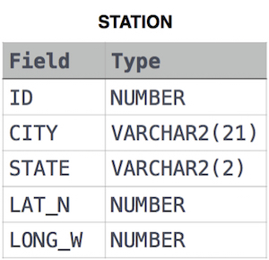

where **LAT_N** is the northern latitude and **LONG_W** is the western longitude.

Ans:

SELECT CITY,STATE FROM STATION;

8. Query a list of **CITY** names from **STATION** for cities that have an even **ID** number. Print the results in any order, but exclude duplicates from the answer.  
The **STATION** table is described as follows:



where **LAT_N** is the northern latitude and **LONG_W** is the western longitude.

Ans:

SELECT DISTINCT CITY FROM STATION WHERE (ID % 2) = 0;

9. Query the list of CITY names starting with vowels (i.e., a, e, i, o, or u) from **STATION**. Your result cannot contain duplicates.

**Input Format**

The **STATION** table is described as follows:



where LAT_N is the northern latitude and LONG_W is the western longitude.

Ans:

SELECT CITY FROM STATION WHERE substr(CITY,1,1) in ('A','E','I','O','U');

10. Query the list of CITY names from **STATION** which have vowels (i.e., a, e, i, o, and u) as both their first and last characters. Your result cannot contain duplicates.

**Input Format**

The **STATION** table is described as follows:



where LAT_N is the northern latitude and LONG_W is the western longitude.

Ans:

SELECT DISTINCT CITY FROM STATION WHERE substr(CITY, 1, 1) IN ('A','E','I','O','U') AND substr(CITY, -1, 1) IN ('A','E','I','O','U');

11. Query the list of CITY names from **STATION** that do not start with vowels. Your result cannot contain duplicates.

**Input Format**

The **STATION** table is described as follows:



where LAT_N is the northern latitude and LONG_W is the western longitude.

Ans:

SELECT DISTINCT CITY FROM STATION WHERE substr(CITY,1,1) NOT IN ('A','E','I','O','U');

12. Query the list of CITY names from **STATION** that either do not start with vowels or do not end with vowels. Your result cannot contain duplicates.

**Input Format**

The **STATION** table is described as follows:



where LAT_N is the northern latitude and LONG_W is the western longitude.

Ans:

SELECT DISTINCT CITY FROM STATION

WHERE substr(CITY,-1,1) NOT IN ('A','E','I','O','U') OR substr(CITY,1,1) NOT IN ('A','E','I','O','U');

13. Write a query that prints a list of employee names (i.e.: the *name* attribute) from the **Employee** table in alphabetical order.

**Input Format**

The **Employee** table containing employee data for a company is described as follows:

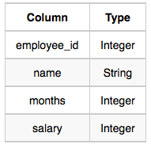

where *employee_id* is an employee's ID number, *name* is their name, *months* is the total number of months they've been working for the company, and *salary* is their monthly salary.

**Sample Input**

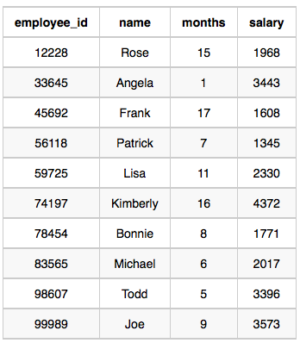

**Sample Output**

Angela

Bonnie

Frank

Joe

Kimberly

Lisa

Michael

Patrick

Rose

Todd

Ans:

1. SELECT NAME FROM EMPLOYEE ORDER BY NAME;
2. SELECT NAME FROM EMPLOYEE ORDER BY NAME ASC;

14.Write a query that prints a list of employee names (i.e.: the name attribute) for employees in **Employee** having a salary greater than  per month who have been employees for less than  months. Sort your result by ascending employee_id.

**Input Format**

The **Employee** table containing employee data for a company is described as follows:



where employee_id is an employee's ID number, name is their name, months is the total number of months they've been working for the company, and salary is the their monthly salary.

**Sample Input**



**Sample Output**

Angela

Michael

Todd

Joe

**Explanation**

Angela has been an employee for 1 month and earns $3443  per month.

Michael has been an employee for 6 months and earns $2017 per month.

Todd has been an employee for  5 months and earns $3396 per month.

Joe has been an employee for 9 months and earns $3573 per month.

We order our output by ascending employee_id.

Ans:

SELECT NAME FROM EMPLOYEE

WHERE SALARY > 2000 AND MONTHS < 10

ORDER BY EMPLOYEE_ID;